Cloud Infrastructure and Services – PCS221
Lab Assignment 5
Name – Sushant Gupta
Subgroup – CS4
Roll No. – 8025320100

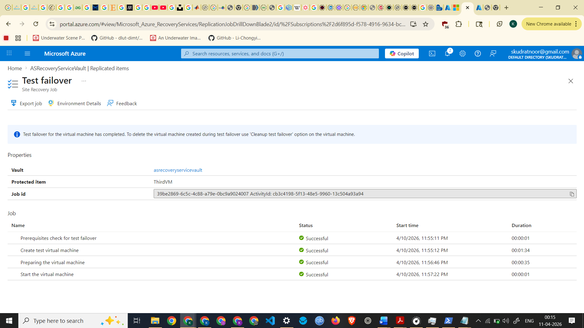
Test Failover Completed

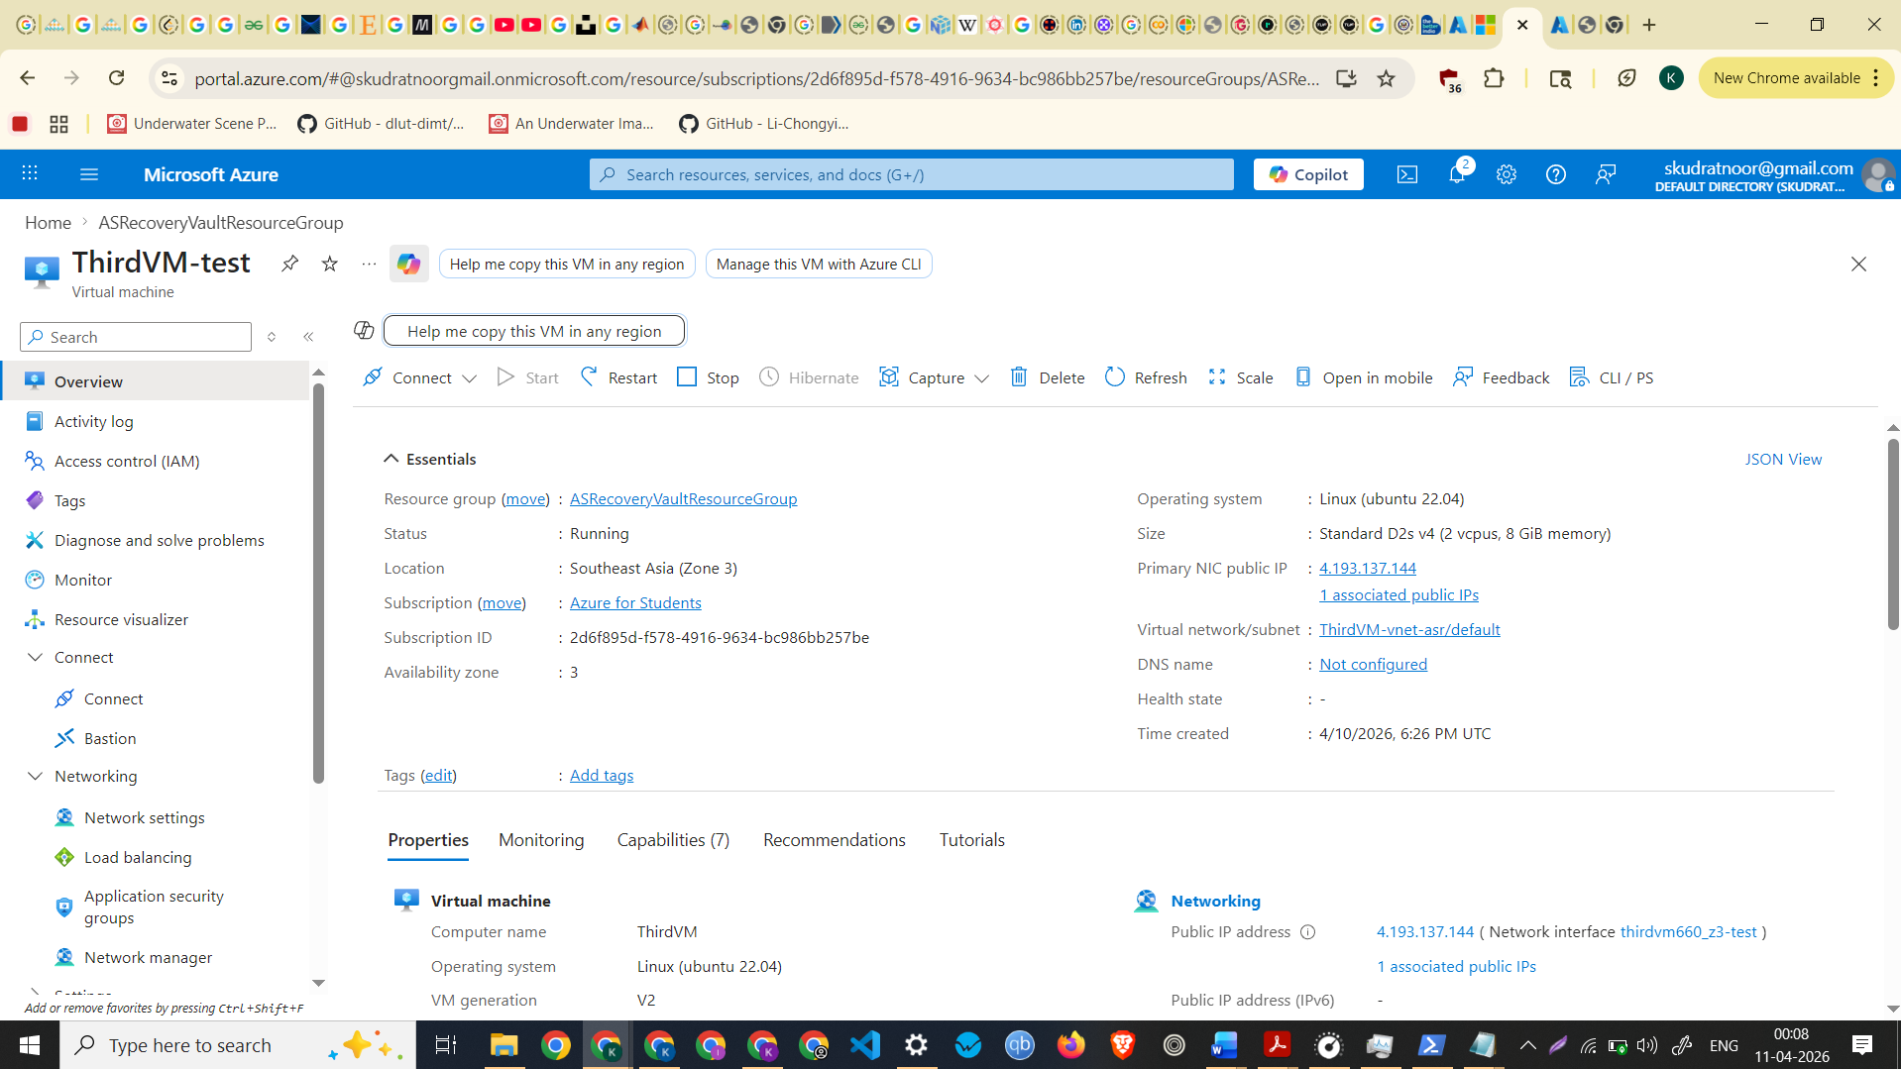
Screenshot of Test Failover VM

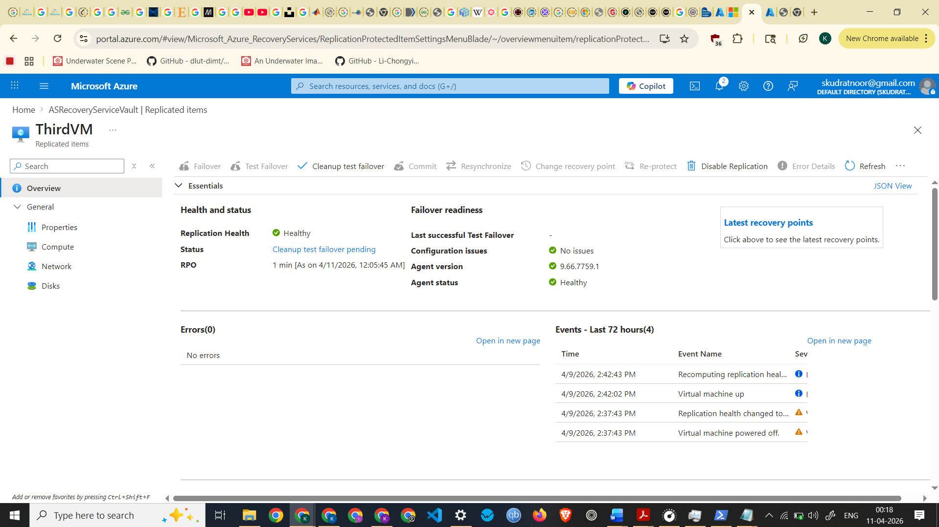

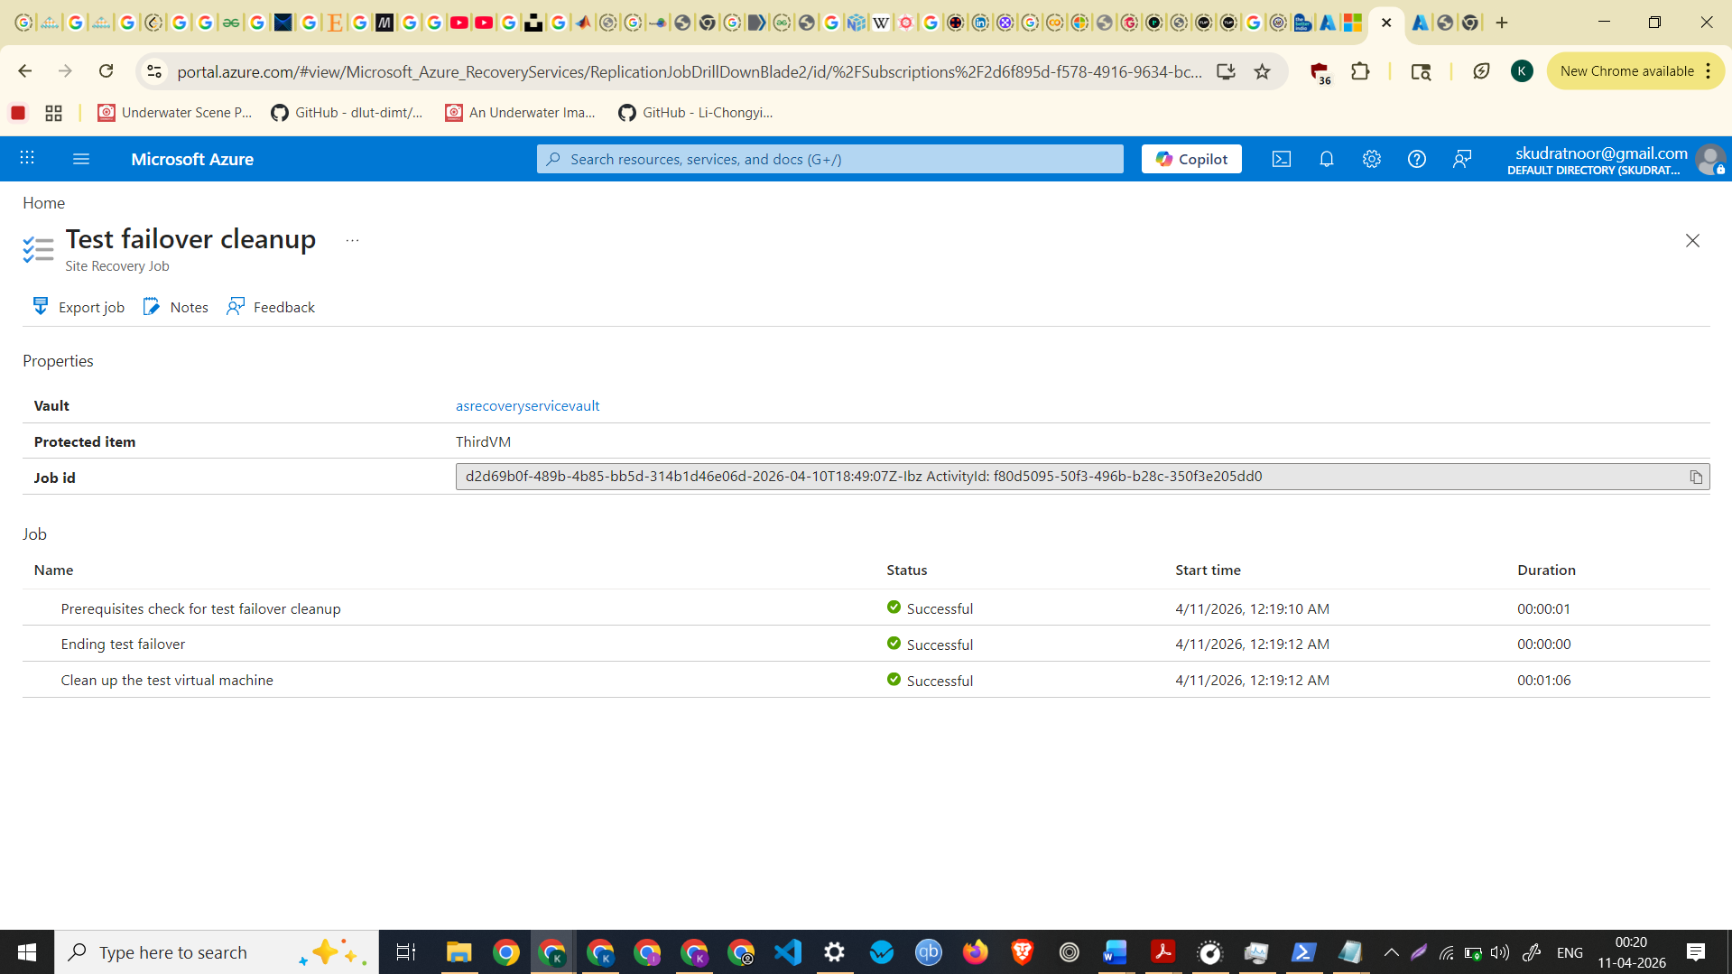
Test failover cleanup completed
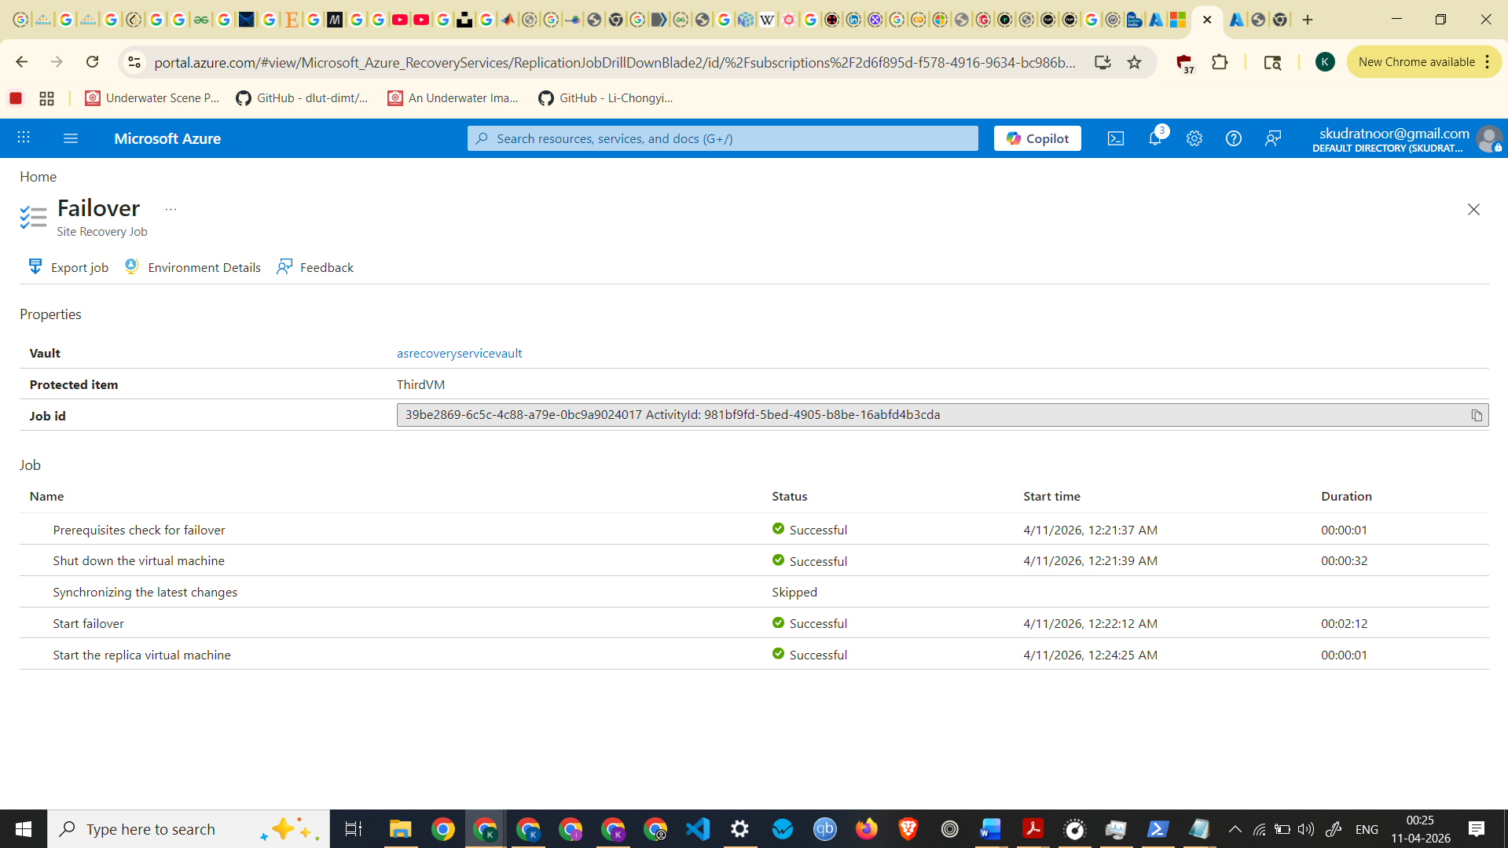
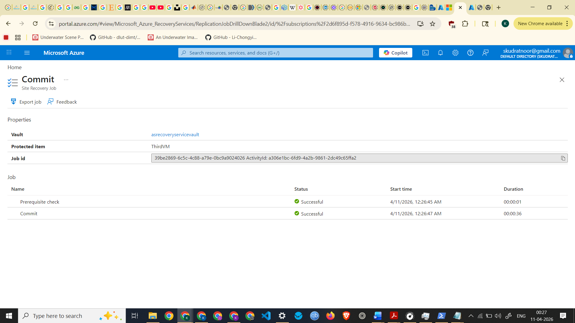
Screenshot of Failover Committed
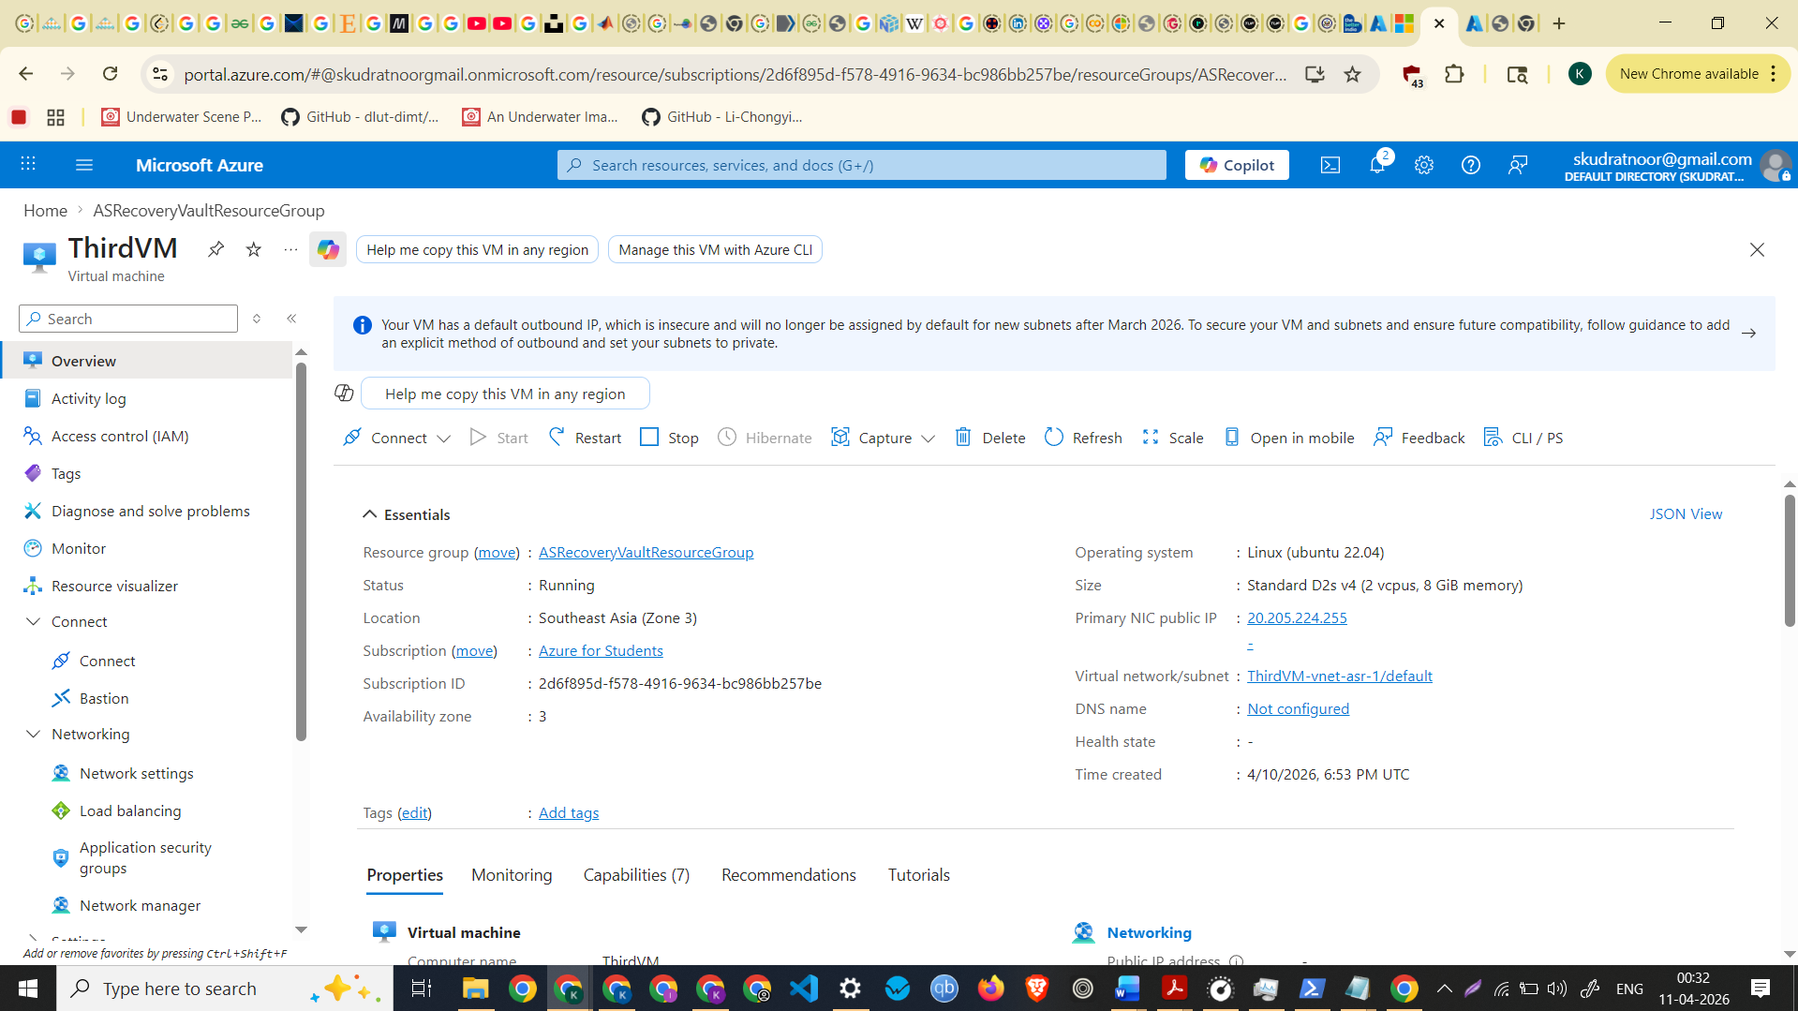
Screenshot of Migrated VM

